***Final Project Report***

***On­­­***

**CUCHD Faculties (Website)**

**Submitted for the requirement of**

**Project course**

BACHELOR OF ENGINEERING

**COMPUTER SCIENCE & ENGINEERING**



**Submitted to: Submitted By:**

(Kirat Kaur & Ecode - E12999)Darshan (20BCS2353)

**Project Teacher (Supervisor)** Sayan Sarkar (20BCS2299)

Vaibhav Bisht (20BCS2272)

**Co Supervisor Signature**

(Mohammed Abdul Wassay & Ecode -E12998)

**DEPARTMENT OF COMPUTER SCIENCE & ENGINEERING**

**CHANDIGARH UNIVERSITY, GHARUAN**

**June 2022**



## BONAFIDE CERTIFICATE

Certified that this project report **“_ CUCHD Faculties [website] ”** is the bonafide work of “ **Darshan, Sayan Sarkar,** and  **Vaibhav Bisht”** who carried out the project work under my/our supervision.



**SIGNATURE SIGNATURE**

**SUPERVISOR HEAD OF THE DEPARTMENT**

Submitted for the project viva-voce examination held on ___________

**INTERNAL EXAMINER EXTERNAL EXAMINER**

### 

**ABSTRACT**

This report is conducted in order to set the foundations upon which the final project. The title of the project is: “CUCHD Faculties”. It is a website that is used to display the data of CU’s faculty members to the students and is supervised by **Kirat Kaur.**

The Primary goal of this website is to make the interaction of students with Chandigarh University faculty members smoothly.

CUCHD Faculties website is developed for CU Students as well as for Faculty by using programming languages HTML, CSS, and Java Script in frontend and PHP and MY SQL in the backend. The main purpose of this website is to help CU Students for finding and searching Faculties/Teachers. Because the university is very large and sometimes students face very difficulty in reaching a particular teacher. But using this website any student can search any teacher/faculty just by pressing one click.

The website provides the following details:

* Faculty Image
* Name
* Contact like phone no or email id.
* Destination
* His or Her Skills
* Qualification

HTML, CSS are used to make the project outlook fascinating. JS is helping in adding some animations on our website. PHP for signup, login, searching and for admin panel connecting. MySQL will be used to collect the data of the teachers or users and for handling databases. In future we are also planning on adding a Chat Bot with the help of AI to assist the new visitors.

**ABSTRACT [In Hindi]**

यह रिपोर्ट उस नींव को निर्धारित करने के लिए आयोजित की जाती है जिस पर अंतिम परियोजना है। परियोजना का शीर्षक है: "CUCHD संकाय"। यह एक वेबसाइट है जिसका उपयोग सीयू के संकाय सदस्यों के डेटा को छात्रों को प्रदर्शित करने के लिए किया जाता है और इसकी देखरेख कीरत कौर करती हैं।  
इस वेबसाइट का प्राथमिक लक्ष्य चंडीगढ़ विश्वविद्यालय के संकाय सदस्यों के साथ छात्रों की बातचीत को सुचारू रूप से बनाना है।  
सीयूएचडी फैकल्टी वेबसाइट को सीयू छात्रों के साथ-साथ फैकल्टी के लिए प्रोग्रामिंग भाषाओं एचटीएमएल, सीएसएस, और जावा स्क्रिप्ट को फ्रंटएंड में और पीएचपी और एमवाई एसक्यूएल को बैकएंड में उपयोग करके विकसित किया गया है। इस वेबसाइट का मुख्य उद्देश्य सीयू के छात्रों को संकायों / शिक्षकों को खोजने और खोजने में मदद करना है। क्योंकि विश्वविद्यालय बहुत बड़ा है और कभी-कभी छात्रों को किसी विशेष शिक्षक तक पहुंचने में बहुत कठिनाई होती है। लेकिन इस वेबसाइट का उपयोग करके कोई भी छात्र किसी भी शिक्षक/संकाय को सिर्फ एक क्लिक दबाकर खोज सकता है।  
वेबसाइट निम्नलिखित विवरण प्रदान करती है:  
• संकाय छवि  
• नाम  
• फोन नंबर या ईमेल आईडी जैसे संपर्क करें।  
• मंज़िल  
• उसका कौशल  
• योग्यता  
  
HTML, CSS का उपयोग प्रोजेक्ट आउटलुक को आकर्षक बनाने के लिए किया जाता है। JS हमारी वेबसाइट पर कुछ एनिमेशन जोड़ने में मदद कर रहा है। साइनअप, लॉगिन, खोज और व्यवस्थापक पैनल कनेक्टिंग के लिए PHP। MySQL का उपयोग शिक्षकों या उपयोगकर्ताओं का डेटा एकत्र करने और डेटाबेस को संभालने के लिए किया जाएगा। भविष्य में हम नए आगंतुकों की सहायता के लिए एआई की मदद से एक चैट बॉट जोड़ने की भी योजना बना रहे हैं।

## ACKNOWLEDGEMENT

### It is my pleasure to be indebted to various people, who directly contributed to the development of this work and who influenced our thinking, behavior and acts during the course of study.

We are thankful to our Project Teacher or Supervisor **Kirat Kaur Mam** for her support, cooperation and motivation provided to us during the training for constant inspiration, presence and blessings.

We would also like to thank our Co Supervisor **Mohammed Abdul Wassay Sir** forher valuable suggestions and precious time which helps us a lot in completion of this project.

Lastly, we would like to thank the almighty and our parents for their moral support and friends with whom we shared our day-to-day experience and received lots of suggestions that improved our quality of work.

**TABLE OF CONTENT**

|  |  |  |
| --- | --- | --- |
| **S. No.** | **Title** | **Page No.** |
| 1. | Introduction …………………………………………………   * 1. Problem Definition.   2. Time line. | 8 to 10 |
| 2. | Literature Survey …………………………………………...  2.1 Objective. | 11 to 12 |
| 3. | Design Flow / Process ……………………………………….  3.1 Features.  3.2 Constraints Identification.  3.3 Analysis of Features & Finalization Subject to Constraints.  3.4 Design Selection.  3.4.1 DFD of the System.  3.4.2 Use Case Diagram.  3.4.3 Sequence Diagram. | 13 to 20 |
| 4. | Results Analysis and Validation………………………….....  4.1 Modern tools Used in Design and Analysis.  4.2 System Specification.  4.3 Project Screen Shots.  4.4 Result Analysis. | 21 to 27 |
| 5. | Conclusion and Future Work………………………………...  5.1 Deviation from expected outcome and ways ahead.  5.2 Achievements.  5.3 Future Scope. | 28 to 29 |
| References…………………………………………………................................................. | | |

## LIST OF FIGURES

1. Figure 3.1[Component Diagram]……………………………………………………………
2. Figure 3.4.1(a)[Level Zero DFD]……………………………………………………………
3. Figure 3.4.1(b)[Level 1 DFD]……………………………………………………………….
4. Figure 3.4.1(c)[Level 2 DFD]……………………………………………………………….
5. Figure 3.4.2(a)[use case diagram]…………………………………………………………...
6. Figure 3.4.3(a) [Sequence Diagram]………………………………………………………...
7. Figure 4.3.1[Front Page]…………………………………………………………………….
8. Figure 4.3.2[Home Page-1]………………………………………………………………….
9. Figure 4.3.3[Home Page-2]………………………………………………………………….
10. Figure 4.3.4[About Page]……………………………………………………………………
11. Figure 4.3.5[Testimonials Page]…………………………………………………………….
12. Figure 4.3.6[Contact Page]………………………………………………………………….
13. Figure 4.3.7[Login Page]……………………………………………………………………
14. Figure 4.3.8[Admin Login Page]……………………………………………………………
15. Figure 4.3.9[Admin Users Page]……………………………………………………………
16. Figure 4.3.10[Admin List Page]…………………………………………………………….
17. Figure 4.3.11[Admin Banner Page]…………………………………………………………
18. Figure 4.3.12[Admin Contact Page]………………………………………………………...

**Chapter - 1**

**INTRODUCTION**

The traditional system used in every college and universities for reaching any teacher is visiting in different classes or in staff rooms and asking other faculties’ members for the particular teacher. CUCHD Faculties website changes this traditional method for CU students. Using this website any CU student can reach or find any teacher/faculty just pressing one click. Due to a digitalized system, the risk of manual errors is eliminated and also helps in saving time.

The website displays all the information that students need to know about the faculty. It has been developed to override the problems prevailing in practicing manual systems. This software is supported to eliminate and in some cases reduce the hardships faced by this in existing or traditional systems. Moreover this system is designed for the particular need of the college/university to carry out operations in a smooth and effective manner.

This website reduces the time of students for reaching any faculty as well as help students by providing different teachers with the same experiences in different fields. It also provides an error message while entering invalid data. The website is user friendly. It can lead to an error free, secure, reliable and fast management system. It can assist the user to concentrate on their other activities rather than concentrating on the record keeping. It will help organizations in better utilization of resources and start steps with the digital world.

This self-searching/reaching to any faculty will be equipped with a user-friendly touch screen, and software for completing the process at the backend. For this CUCHD Faculties application there will be a system administrator who will have the rights to enter the new faculties’ details with their current photo and experience. The administrator also has rights to manage front page banners, manage chat sections, check the registered users/students, and adding, editing or deleting teachers/faculties details.

Now when any user or student needs to meet any faculty outside his/her range then he/she can login the website and get a list of all teachers you can check here manually by scrolling or by using search bar simply writing the name and will get desired output. The website also helps in finding data by block wise. This feature helps students to find two or more teachers having the same experience in a particular field so that students can take advice or notes on a particular topic with different teachers in the same block.

The System is designed using programming languages HTML, CSS, Java Script, PHP, and MYSQL. Uses of HTML, CSS are for making the project outlook fascinating and frame work. JS [Java Script] is helping in adding some animations on our website. PHP for signup, login, searching and for admin panel connecting. MySQL will be used to collect the data of the teachers or users and for handling databases. Along with these languages for designing UI/UX and logo designing we use Canva and digrams.net platform.

There are two entities that will have access to the system. One is the admin and another one will be the registered user/student. Admin can add faculty details, view all the registered users details and also view the get in touch form or front page banners details.

The future update of CUCHD Faculties system is adding an AI chat bot which helps the users in getting their queries answers like searching problem, site handling problem, etc. AI Bot also helps in suggesting faculties for a particular problem or for a particular topic using faculties’ skill database and saves the time of students.

**1.1 Problem Definition:**

The purpose of every website/app is to help customers or users in different ways. For example an e-commerce website helps their users narrow down their broad ideas and enable them to finalize the products they want to purchase and also help in time saving and money saving. In the same way CUCHD Faculties website is useful for making relationships or mutual understanding between CU students and teachers.

Main problem faced in every college or university in traditional methods is reaching to a particular teacher. Because universities are very big and number of students and teachers are in thousand’s. It is sometimes very difficult to find a teacher. It also consumes a lot of precious time in visiting every class or in every staff room and asking different teachers and students. As a student I also face this issue many times. That's why I and my team plan a model for everyone that is CUCHD Faculties website.

The CUCHD Faculties system overcomes this type of problem faced by CU students. Using this website any student can easily reach any teacher just pressing one click without going anywhere. Here students/users get a very user friendly and attractive interface. Anyone can visit login and get a home page with a list of all faculties’ details with a photo. He/she can search manually by scrolling down or by using a search bar. The website also provides category wise or block wise search options.

**1.2 Time Line:**

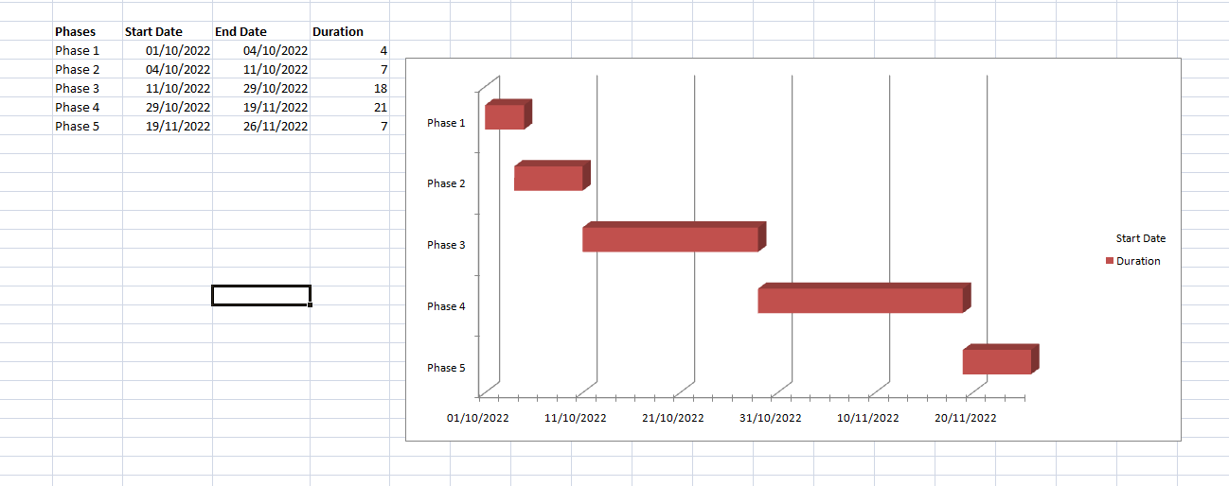

**Chapter – 2**

**LITERATURE SURVEY**

CUCHD Faculties is a solution to the problems faced by both students and faculties on a daily basis, i.e, efficient communication of information and queries. CUCHD Faculties website provides the solution to this problem by providing a platform that is purely meant for this specific problem.

CUCHD Faculties helps you by:

[1] Providing a platform for both queries and information sharing by direct messaging. There is a great problem for both students as well as the teachers to communicate after classes be it meeting in the staff room or by calling or messaging. CUCHD Faculties' messaging feature will totally save the work life balance of the teachers and students as there is no need of messaging the queries and info on whatsapp or mails where there are personal messages too and the messages gets unnoticed.

[2] CUCHD Faculties would be providing each and every detail of the teacher to the students.

[3] It is easy for the management to update the information of each and every teacher.

[4] It is a kind of information Directory for the entire University where you can get the information of any teacher without calling the helpline.

[5] The total front end was dominated using HTML standards applied with the dynamism of PHP server pages. At all proper levels high care was taken to check that the system manages the date consistency with proper business validations. The database connectivity was planned using the MYSQL Connectivity, the authorization and authorization was cross checked at all stages. The user level accessibility has been restricted into two zones: the administrative and the normal user zone.

[6] The system is implemented to reduce manual work and enhances the accuracy of work. This system manages and maintains the record of students or users and all faculties online. This Website App has been made in a user friendly interface. So that user can use and search the faculties easily.

**2.1 Objectives**

The Primary goal of this project is to make the interaction of students with Chandigarh University faculty members smooth and secondary goal of this CUCHD Faculties website is to display the data of CU’s faculty members to the students, so the students can reach their respective faculty members easily.

Functionalities provided:

1. Provides the searching facilities based on various factors such as block wise details, engineering and non-engineering staff, search by name or Eid, etc.

2. Manages the faculties’ details.

3. Manages the information of the university.

4. To increase efficiency of reaching to the faculty.

5. Deals with monitoring the information and registered users of the website.

6. Manage the information of users and banners.

7. Editing, adding and updating of records is improved which results in proper resource management of website data.

8. Manage the information of the database.

9. Chat assistant is added to assist new users.

10. Complete interface is attractive and user friendly.

**Chapter – 3**

**DESIGN FLOW/PROCESS**

**3.1 Features**

There are the following features of CUCHD Faculties Websites are:-

1. **User-Friendly System:** The interface of the system is user friendly and interactive. If any new student comes he /she can easily use the CUCHD Faculties website to find his / her required information about the faculty.
2. **Security-Management:** CUCHD Faculties web has good Security, for guarding information regarding the Chandigarh University faculty Members, only students of Chandigarh University and faculty members of Chandigarh university can access the information which will be presented on the website.
3. **Information-Handling:** CUCHD Faculties website has good user friendly interface which distribute the Information among the students and faculty members. The website clearly sorts the information between engineering department and Non-Engineering department and further it sort the information in respective of university blocks.

This gives the user too finally to look into required information with the blocks mentioned.

**3.2 Constraints Identification**

The following Constraints come in the project:

1. **Time:** Time is the first constraint in designing the CUCHD Faculties website. Time is a key element to a project’s success. After all, what good is a finished product if it is completed long after the expected deadline? To overcome this constraint our project team first design the time table and divide the project according to the time table. Time Management also helps in increasing the speed of the project.

1. **Quality:** Quality is another constraint that the system has. The quality constraint focuses on the characteristics of the deliverable or product. In general, the quality of the project will be evaluated by how closely the outcome matches the expectations set in the planning stages.
2. **Students Satisfaction:** Another constraint to bear in mind is customers/students satisfaction. When thinking about customer satisfaction as a constraint, our team needs to keep in mind that we design a simple and interactive user interface. So to overcome this constraint we add JavaScript to the website for a responsive and interactive look.
3. **Resources:** Resources is one of the constraints that we face in designing the project. To avoid the effects of this constraint our team takes help of Google, teachers, friends and also collects the resources from different other websites.

**3.3 Analysis of Features & Finalization Subject to Constraints**

Despite having a lot of constraints and risks, till now, we have achieved the feat of minimizing them and we hope to do so in the upcoming phases of the project. After analyzing all the aspects of our project i.e. features and possible constraints, we have decided on certain features for our project that will be suitable.

Major among them are listed below:

**Live Chat:** A live chat or AI chat is a feature where your operators initiate the chat and reach out to your website visitors by offering instant help. This is a powerful tool for increasing customer satisfaction and engagement.

**Data Extend & format:** In feature updating the website our team make plane for adding new data, categories and voice searching for making the web smooth and attractive so that range of students/users is increase in the website.

**Analytics and reporting:** Analytics gives you visibility into key areas of your operation and is arguably the most defining feature of the software. We can use analytics to know which problems to attack first. We can analyze this using Customer or user data, time spending and menu analytics and Inventory and procurement analytics.

**3.4 Design Selection**

The CUCHD Faculties system is designed based on a mixture of multitier architecture, RESTFUL architecture style [5] and Model View View Model (MVVM) pattern [7]. The multi tier architecture provides a model to create flexible and reusable components in a web application. It segregates the application into several tiers, where developers can add/modify the functionalities on a certain tier instead of modifying an entire application. This allows the functionalities of the system to extend for future development.

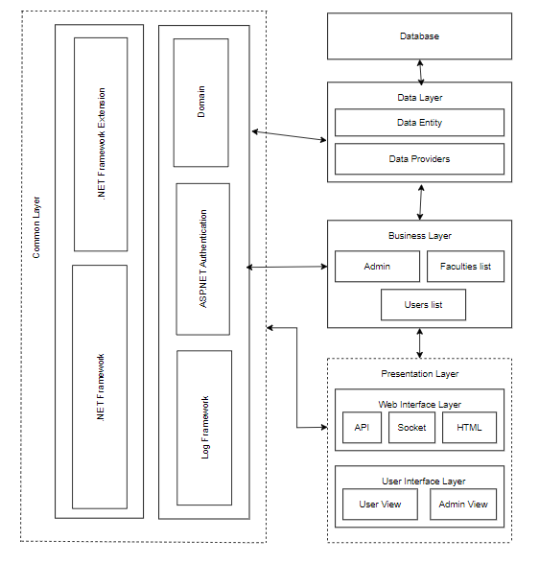

Figure 3.4.1[Component Diagram]

The RESTFUL architecture style provides core functionalities of the system as web services for different devices and platforms as mentioned in requirements R1, R2 and R5. The MVVM pattern [7] allows developing the User Interface (UI) with clear separation of UI components and presentation logic. The core system has three main layers: Data Layer, Business Layer and Presentation Layer. The Presentation Layer is further divided into two layers, namely Web Interface and UI Layers. These two layers are loosely coupled and connected with web services. All these layers are cross-connected with the Common Layer, as shown in Figure 4.1.

* + 1. **DFD of the System:**
* Level Zero Diagram:

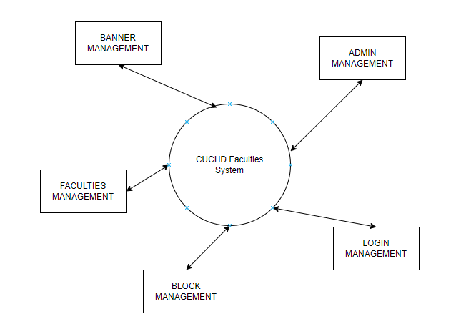

Figure 3.4.1(a)[Level Zero DFD]

* Level One Diagram:

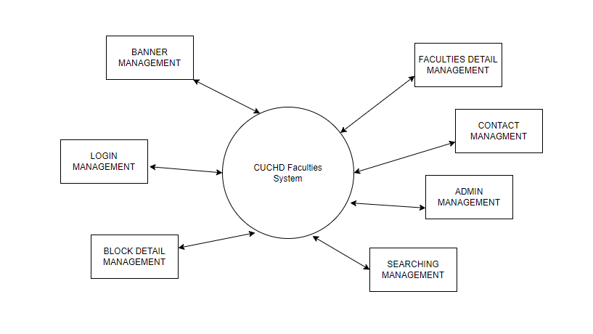

Figure 3.4.1(b)[Level 1 DFD]

* Level Two Diagram:

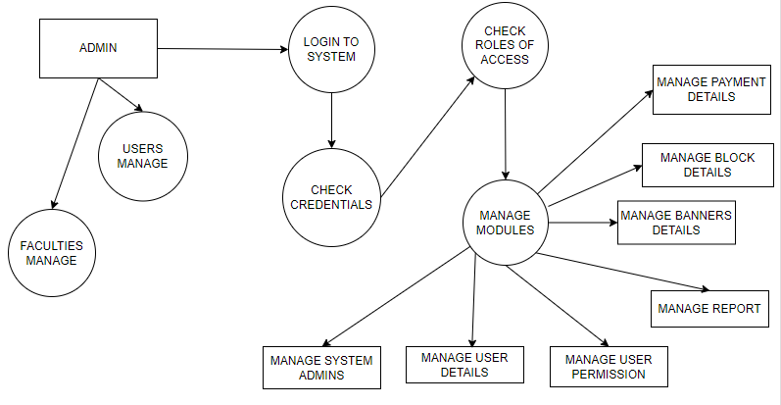

Figure 3.4.1(c)[Level 2 DFD]

* + 1. **Use Case Diagram:**

Use-case diagrams describe the high-level functions and scope of a system. These diagrams also identify the interactions between the system and its actors. The use cases and actors in use-case diagrams describe what the system does and how the actors use it, but not how the system operates internally.

Here users and admin are the actors and the working of the system is use cases.

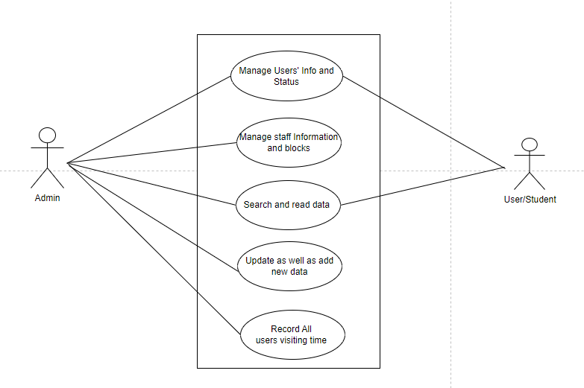

Figure 3.4.2(a)[use case diagram]

* + 1. **Sequence Diagram:**

A sequence diagram is a type of interaction diagram because it describes how—and in what order—a group of objects works together. These diagrams are used by software developers and business professionals to understand requirements for a new system or to document an existing process. Here this sequence diagram shows how the system works in step by step.

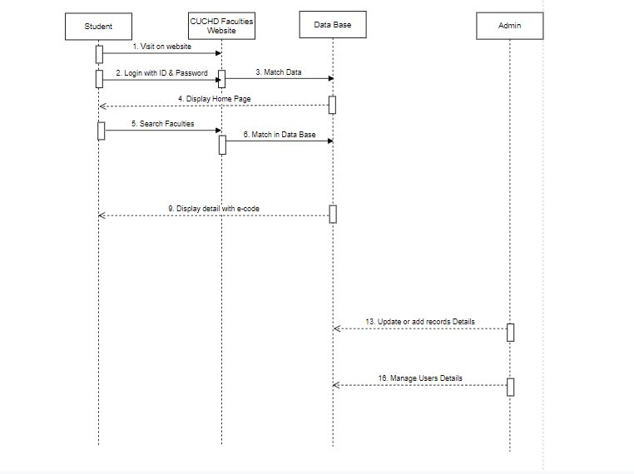

Figure 3.4.3(a)[Sequence Diagram]

**Chapter – 4**

**RESULTS ANALYSIS AND VALIDATION**

**4.1 Modern Tools Used In Design and Analysis:**

The name ‘CUCHD Faculties’ suggests that this is any college or university website. So we use many programming languages like HTML, CSS, JS, PHP, My SQL, and many more. To handle these languages we use entire initial tools that we need for making any website.

**Software tools:**

* **VS Code**:

Visual Studio Code is a streamlined code editor with support for development operations like debugging, task running, and version control. It aims to provide just the tools a developer needs for a quick code-build-debug cycle and leaves more complex workflows to fuller featured IDEs, such as Visual Studio IDE.

* **My SQL**:

MySQL is an open-source relational database management system. Its name is combination of “My”, the name of co-founder Michael Widenius's daughter, and "SQL", the abbreviation for Structured Query Language. In CUCHD Faculties this use for making the database of the whole website

* **XAMPP Server**:

XAMPP helps a local host or server to test its website and clients via computers and laptops before releasing it to the main server. It is a platform that furnishes a suitable environment to test and verify the working of projects based on Apache, Perl, MySQL database, and PHP through the system of the host itself.

* **Tawk.to**:

Tawk.to is a site that provides chat bot to CUCHD Faculties web. This provides live chat as well as inbuilt chats to the users. Which helps the clients if they face any problem in operating the website?

* **Pinterest**:

Pinterest is a social site where you can collect and share images of anything you find interesting. You can also visually discover new interests by browsing the collections of other [Pinterest users](https://www.lifewire.com/most-popular-pinterest-users-to-follow-3485976). We use this site for collecting all the images for the website.

* **Sublime text**:

Sublime Text is a shareware cross-platform source code editor. It natively supports many programming languages and markup languages. Users can expand its functionality with plug-in, typically community-built and maintained under free-software licenses. To facilitate plug-ins, Sublime Text features a Python API. The whole CUCHD Faculties website phages are done in the sublime text editor. This is an advanced editor which mainly helps in making HTML, CSS, JS, PHP files.

**4.2 System Specification**

The hardware and software requirements for the development phase of our projects are:

**Software requirements:**

* Windows 10/ 11
* VS Code.
* Mysql
* XAAMP Server

**Hardware requirements:**

* Dual-core 64-bit processor.
* Upto 4GB of memory.
* Upto 4GB of internal storage Android SDK:2GB
* Windows SDK: 4GB.
* Network interface card

**4.3 Project Screen Shots**

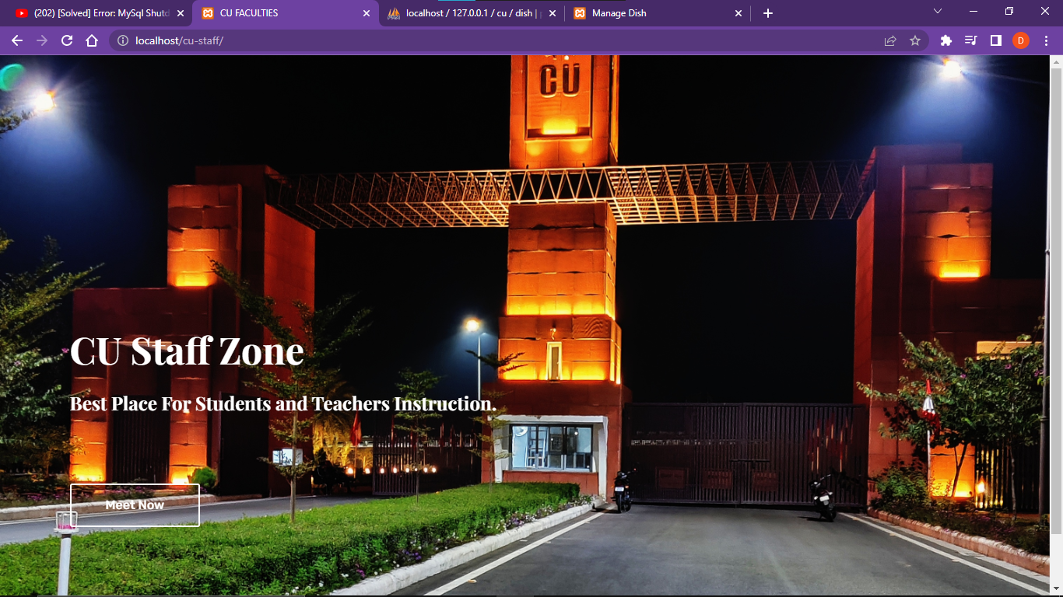

Figure 4.3.1[Front Page]

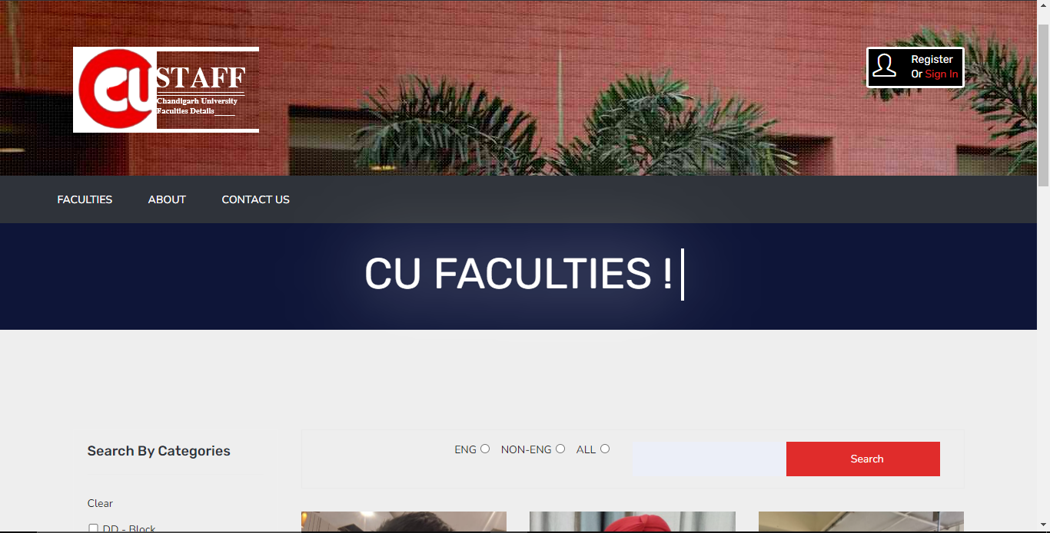

Figure 4.3.2[Home Page-1]

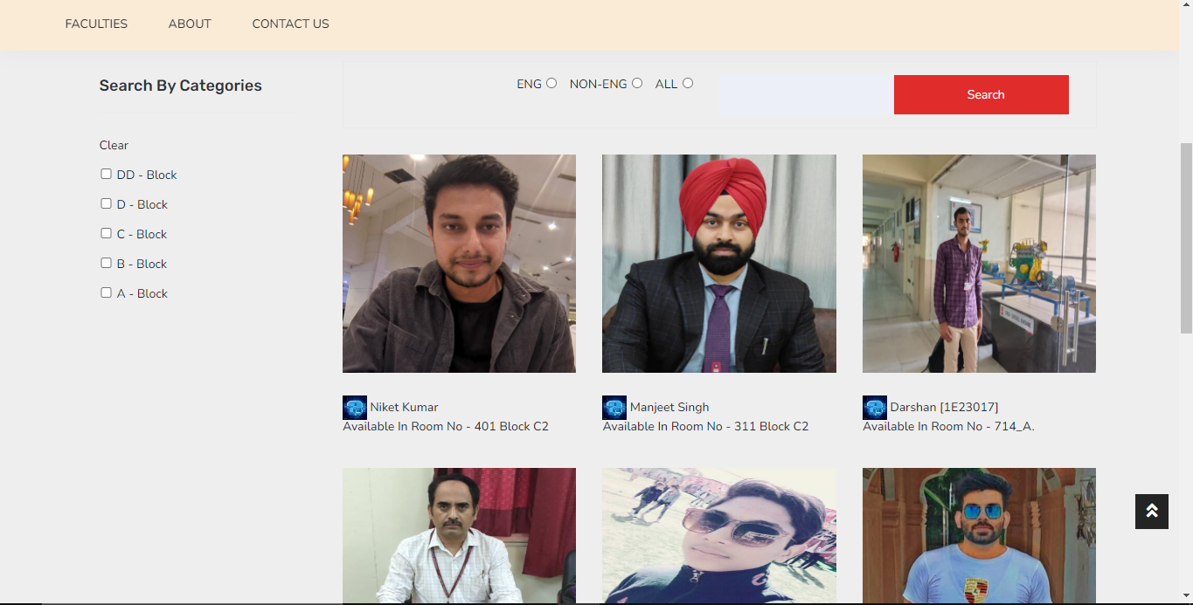

Figure 4.3.3[Home Page-2]

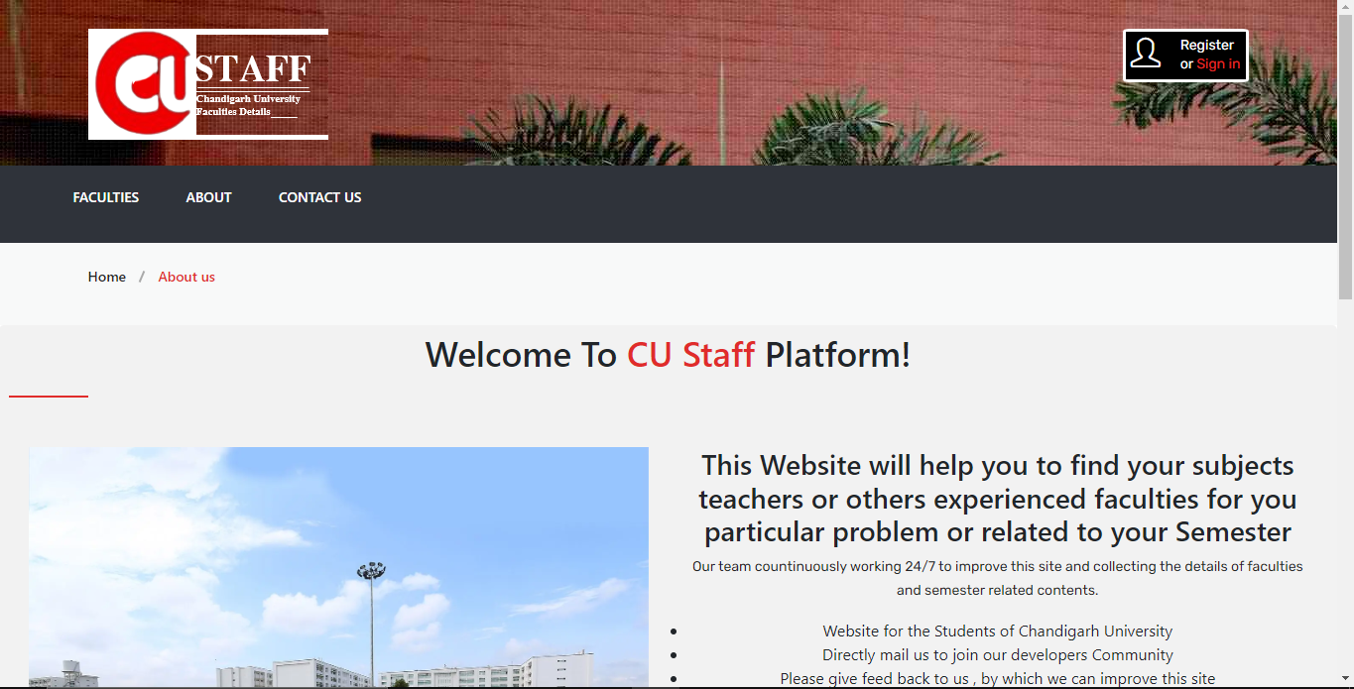

Figure 4.3.4[About Page]

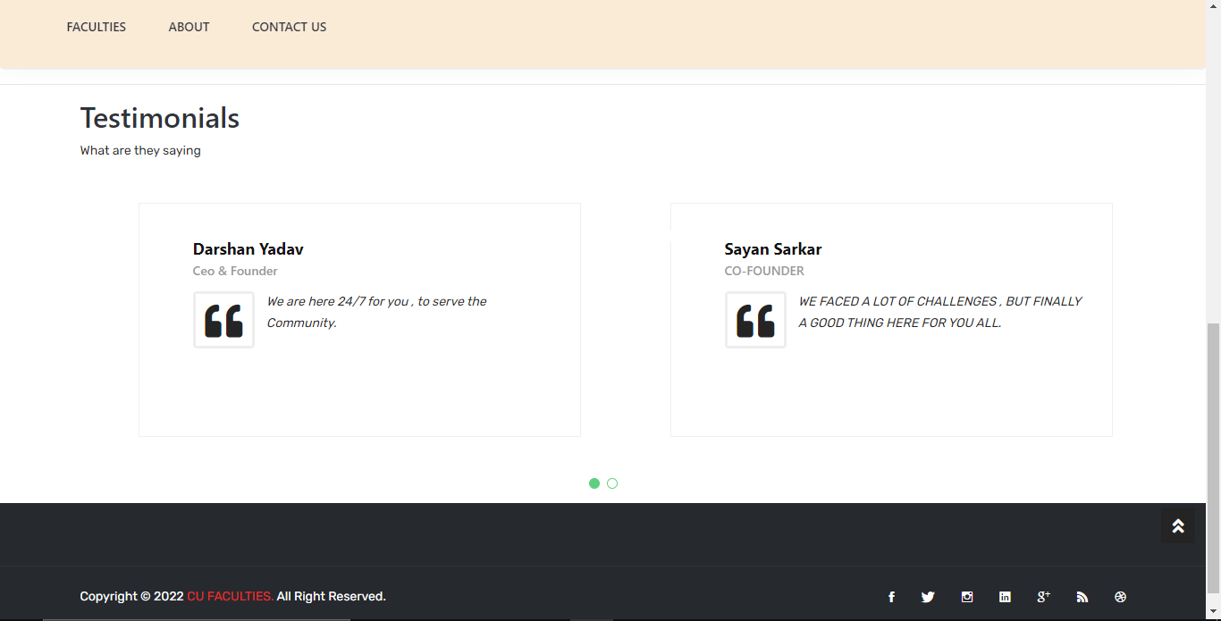

Figure 4.3.5[Testimonials Page]

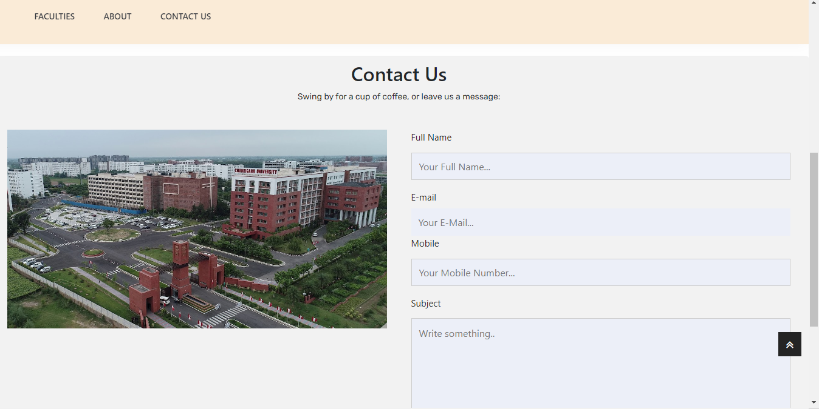

Figure 4.3.6[Contact Page]

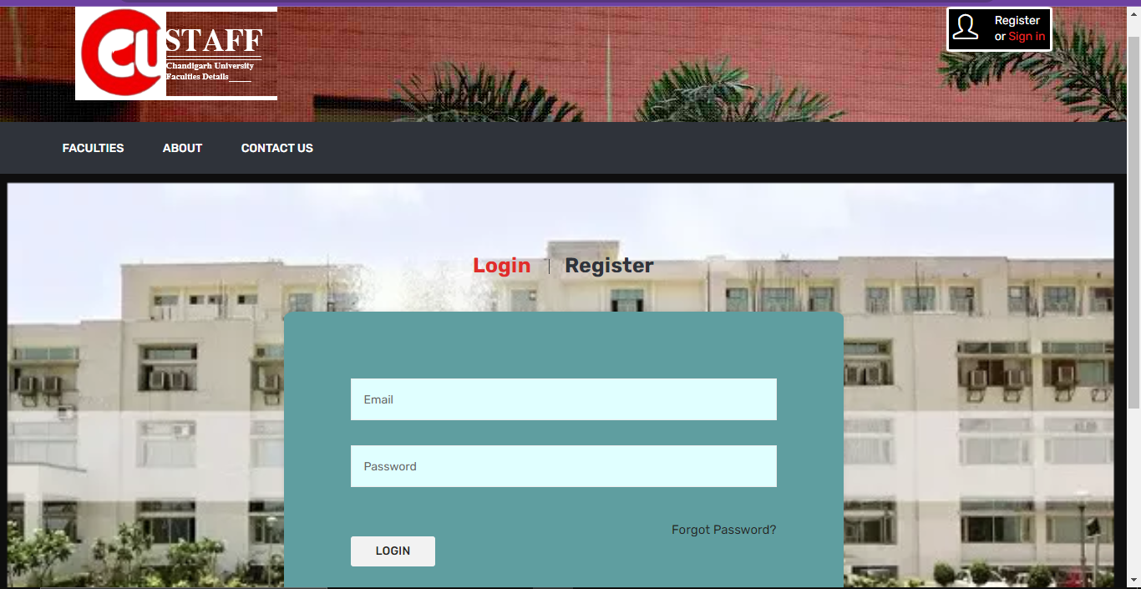

Figure 4.3.7[Login Page]

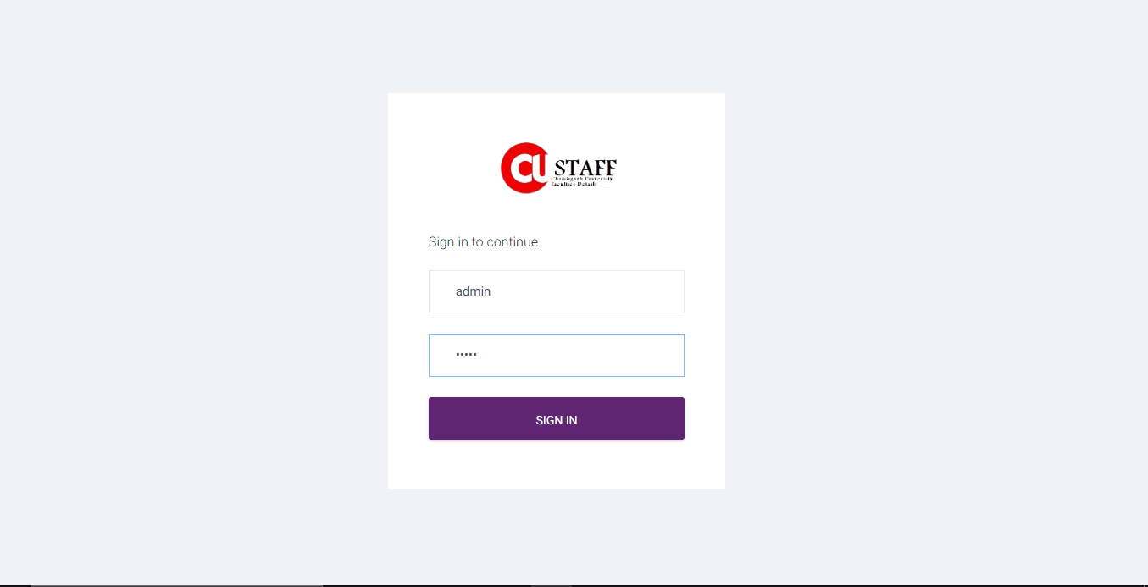

Figure 4.3.8[Admin Login Page]

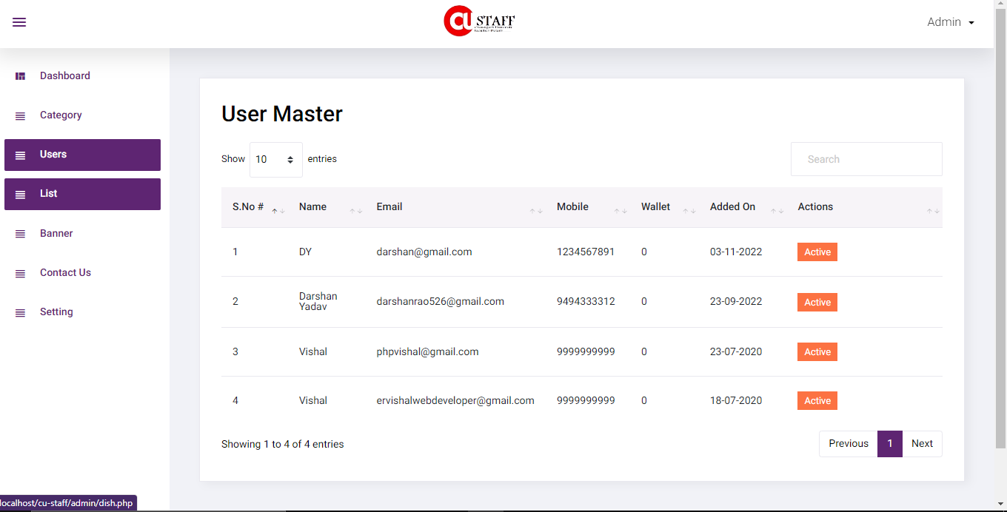

Figure 4.3.9[Admin Users Page]

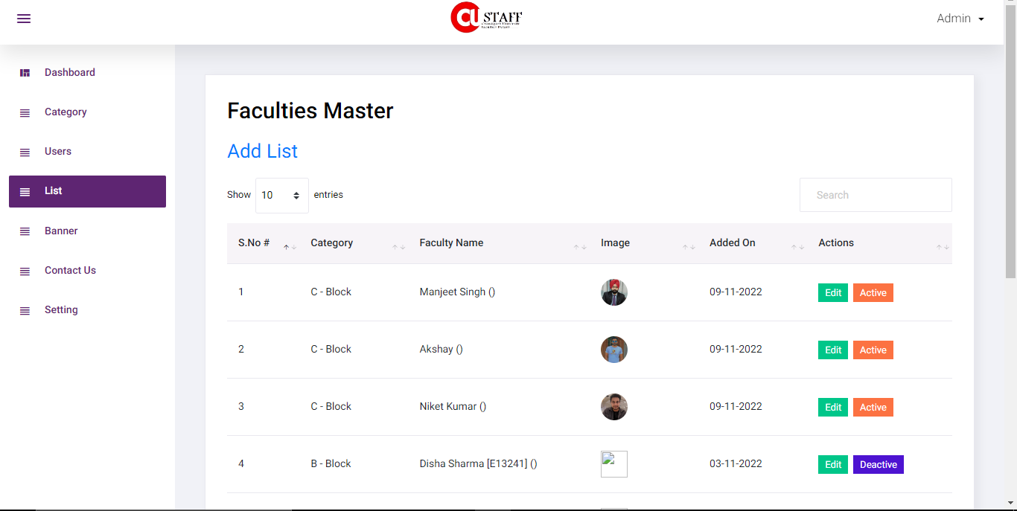

Figure 4.3.10[Admin List Page]

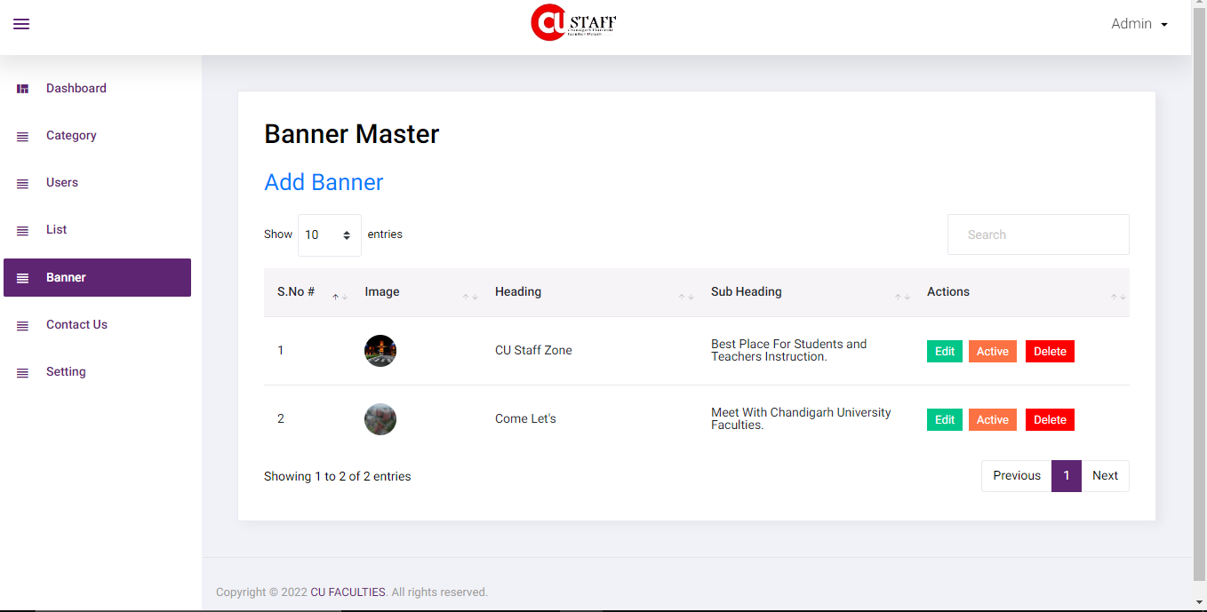

Figure 4.3.11[Admin Banner Page]

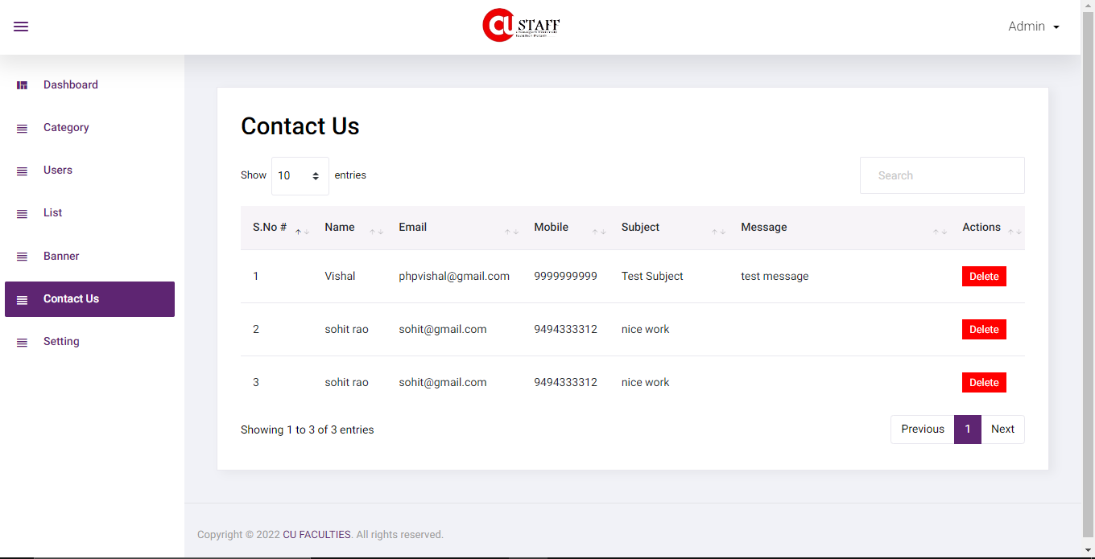

Figure 4.3.12[Admin Contact Page]

**4.4 Result Analysis**

Despite having a lot of constraints and risks, till now we have achieved the feat of minimizing them and we hope to do so in the upcoming phases of the project. After analyzing all the aspects of our project i.e. features and possible constraints, we have decided on certain features and possible constraints, we have decided on certain features for our project that will be suitable.

Major among them are listed below:

**Live Chat:** A feature where your operators initiate the chat and reach out to your website visitors by offering instant help. This is a powerful tool for increasing customer satisfaction and engagement.

**Data Extend & format:** In feature updating the website our team make plane for adding new data, categories and voice searching for making the web smooth and attractive so that range of students/users is increase in the website.

**Analytics and Reporting:** Analytics gives you visibility into key areas of your operation and is arguably the most defining feature of this software. We can use analytics to know which problems to attack first. We can analyze this using Customer or user data, time spending and menu analytics and Inventory and procurement analytics.

**Chapter – 5**

**CONCLUSION AND FUTURE WORK**

**5.1 Deviation from expected outcome and ways ahead**

The main outcome of this project is to increase the connection between faculties and students. It also manages all the information of faculties and provide user interactive interface. The project is totally built at the administrative end and thus only the administrator is guaranteed the access of updating and adding the content. The purpose of the project is to build a website to reduce the manual work for reaching to a particular teacher in CU. It tracks all the details about the users.

There are the following outcomes that the project reach are:

* **Improve Relationships:**

Well, the CUCHD Faculties is designed on the basis of improving users/students and teachers relationships. The website is very user friendly and very interactive. When any new user comes here he/she can easily handle or search their teacher destination in a few minutes at anytime and anywhere just pressing one click.

* **Tracking Users:**

The website also provides users tracking facility to the admin. The CUCHD Faculties website track no of active users, dally users and spending time on the website by the users.

* **Automatic Analysis:**

As a matter of fact, this CUCHD Faculties software can automate the report generation. The site is designed in this way the admin can see all the reports of the university faculties on their dashboard like the detail of new, old, updated and active & de-active staff. In fact, it produces perfect reports of users/students as well as contact form fills the students. It helps the students of CU for making a strong bond with teachers.

* **Enhanced Productivity:**

The CUCHD Faculties site sends all the products report to the admin. So this helps the admin to enhance productivity of the products very easily. So this is one of the most important outcomes of the software.

**5.2 Achievements**

Well, we achieved the objectives of our project such as we made the CUCHD Faculties site as a user friendly and very interactive user interface. We also add online chat option in website. For storing the user’s data we use a register and login page. Now come on the admin panel. The admin panel is very user friendly. Here the admin can add, delete and update any data just pressing one click. Also the admin can see all the users and banner of the university in the admin panel.

**5.3 Future Scope:**

As we know in the modern era people are going to do more importance to the time. People like to spend more and more time with technology. So the CUCHD Faculties website is one of the part technologies with mainly designed for CU students and faculties. Website provides the destination of all the teachers at one place without going anywhere. Anyone can search and reach their teacher just using their Smartphone. It saves time of students. The user can register or login and very easily search any teacher. In future we will also plan of adding new features like ChatBot option, voice search etc. Chatbot helps the new users if they get any problem in using the website and voice search help in making user interactive interface.

**References**

1. Kancho Dimitrov Kanchev “Employee Management System” (Dec 2006) https://lnu.diva-portal.org/smash/get/diva2:204828/FULLTEXT01.pdf
2. Programming with Vishal “e-commerce website in php”(14 Jan 2020) https://www.youtube.com/watch?v=QsAVoLPqkRQ&list=PLWCLxMult9xfYlDRir2OGRZFK397f3Yeb
3. Vishal “Cafeteria Management System” (May 2022) <https://github.com/Darshan-star/project1-report/blob/main/CAFETERIA%20MANAGEMENT%20SYSTEM.pdf>
4. Funda Of Web IT “PHP Blog Part-4 [-A-]: Faculty Page | Fetching image & data from Database (ADMINPANEL)” (4 Aug 2019) https://www.youtube.com/watch?v=WoftcZDfeoQ
5. W3 Schools https://www.w3schools.com/

Edition”, Canada, 1997.